Architectural Design and Design Tradeoffs

The architecture design is composed of the use case that will be used and the processes.

The Use Case includes:

Strike Target

Brief Description: The user will have the ability to input what row and column they want to strike.

New Game

Brief Description: The user can start a new game.

Choose Difficulty

Brief Description: The user can choose between easy, medium, and hard altering how many aircrafts are shown.

Read Rules

Brief Description: User can read rules to the game.

Change Color

Brief Description: User can change game color theme.

Quit Game

Brief Description: User may exit game.

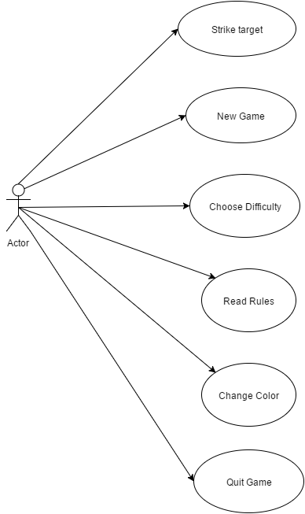

Example of a process:

In this example when Strike Target is initiated the following functions are performed sequentially.

